LAB 2: DISPLAYING A SIMPLE STDENT TABLE USING ASP.NET WEB APPLICATION

FILE STRUCTURE

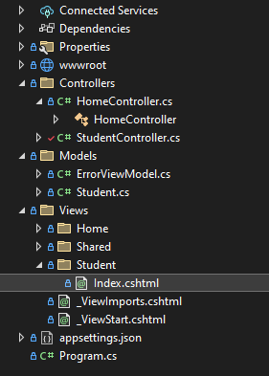

S

StudentController.cs

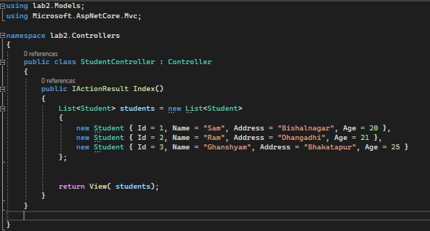

Student.cs

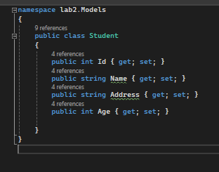

OUTPUT

